# CPE-640 project:discussion board

The home page:

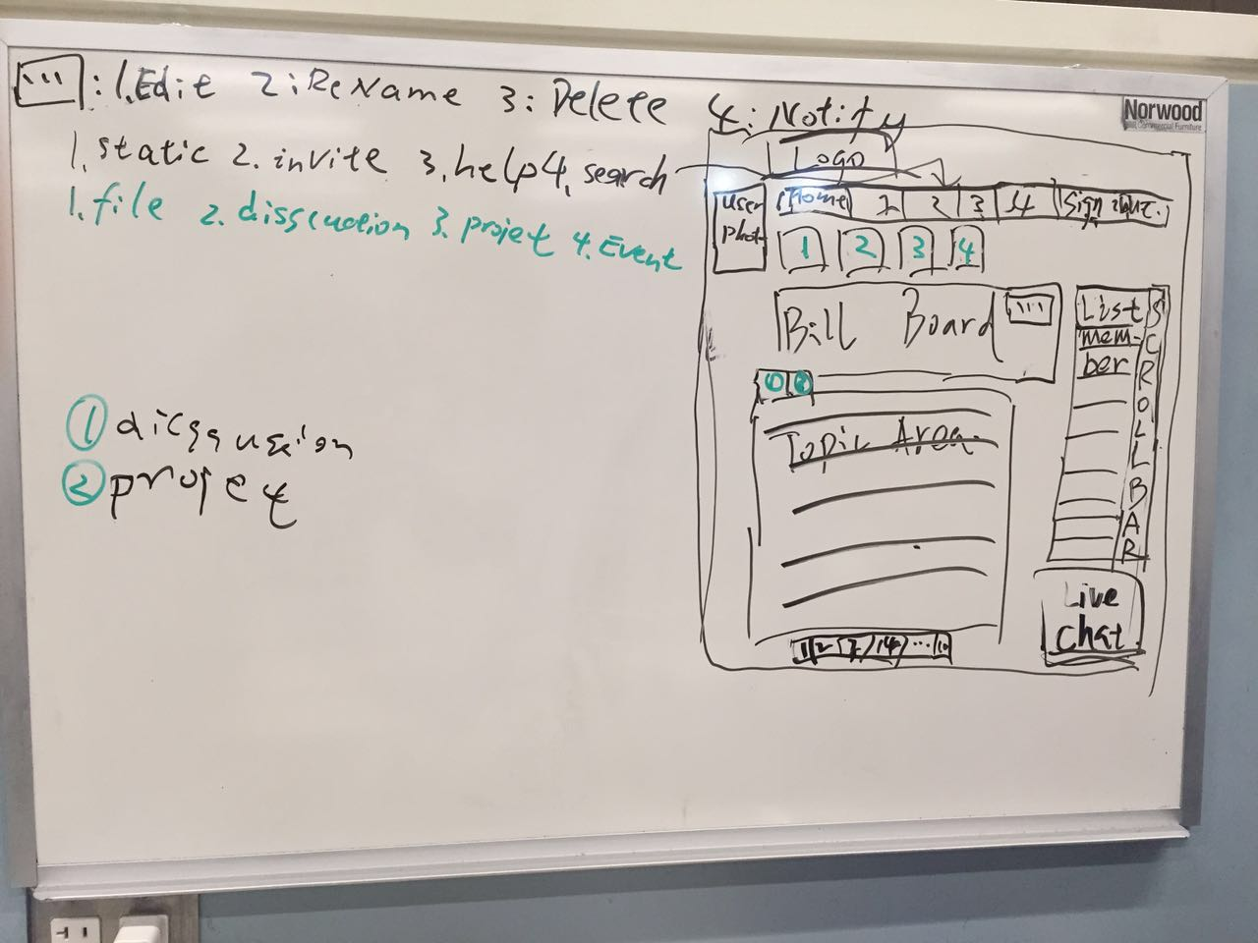

What our project is based on wikispace which is a great website for student to discuss their project or course.

Our wikispace:<http://640project.wikispaces.com/>

Our project have Five main functions:

1.create or post a topic or project

2.live chat(or we just linked to the skype use their soultions)

3.statics: which can show how many pages or project we create. What is each member contribution which is also include in the wikispace:

4.bill board which teacher can give student a notification.

5.list each class numbers status (on/off line) so you can talk with them.

Wiki space statics:

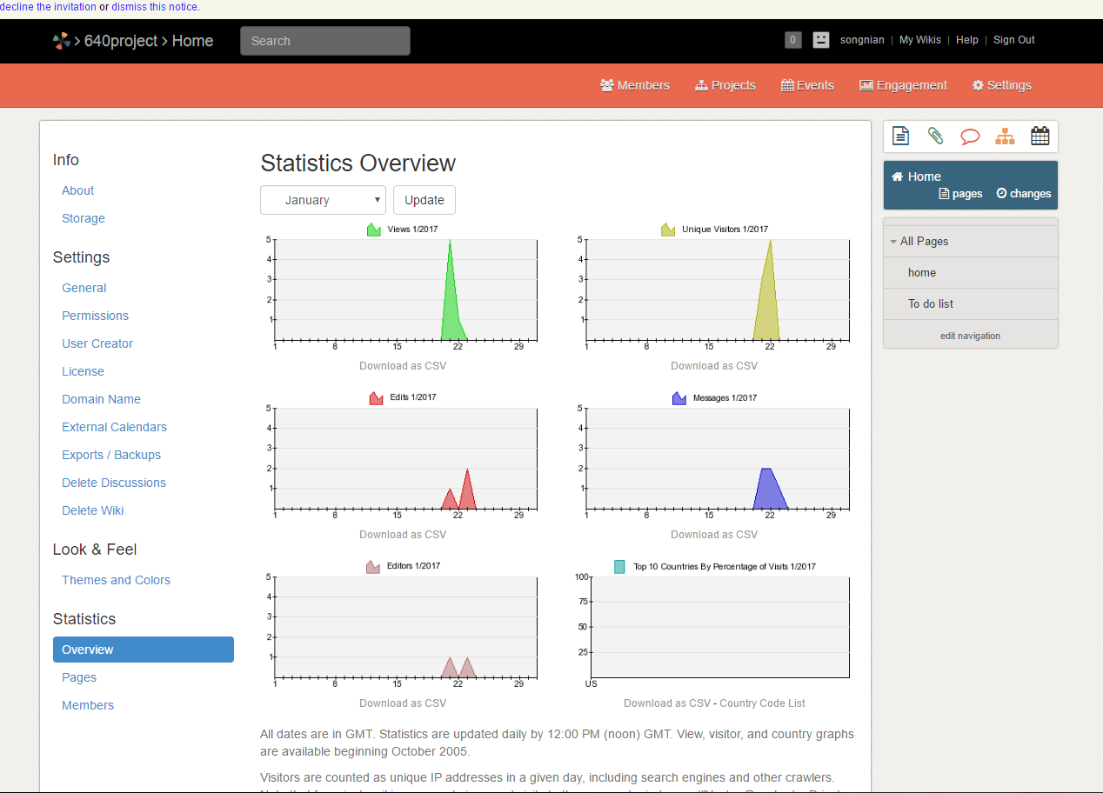

We will also keep the top bar on the wiki space, so people can upload file, create discussion, project and events.



Right now we have not agree with who will do what, but our first meeting are going to be at Thursday 7:00 PM. During the meeting, we will decide who will do what.

What we are going to use is bootstrap which is great front-end framework. It make the web page more easily to build.

<http://getbootstrap.com/>

You can learn it from youtube.

And the example we are going to use this one:the example is at /doc/example/offcanvas

<http://getbootstrap.com/examples/offcanvas/#>

And we will change it to our need.